APUSH Syllabus
Advanced Placement United States History
Mr. Preisse
The Course: This course is designed to teach students to think critically about the issues that have confronted and influenced the United States through a process that integrates the examination of factual knowledge, the development and application of analytic skills, and the assessment of primary and secondary sources. This class is the equivalent of an introductory college survey course in U.S. history, and its content spans the discovery and settlement of the New World to the present.

From the 2015 revised framework:
“The AP U.S. History course focuses on developing students’ understanding of American history from approximately 1491 to the present. The course has students investigate the content of U.S. history for significant events, individuals, developments, and processes in nine historical periods, and develop and use the same thinking skills and methods (analyzing primary and secondary sources, making historical comparisons, chronological reasoning, and argumentation) employed by historians when they study the past. The course also provides seven themes (American and national identity; migration and settlement; politics and power; work, exchange, and technology; America in the world; geography and the environment; and culture and society) that students explore throughout the course in order to make connections among historical developments in different times and places.”

AP United States History students will:
Develop thinking skills and enduring understandings necessary to deal critically with the main issues and documents of U.S. history Prepare for intermediate and advanced college courses by making demands equivalent to those made by full-year introductory college courses Analyze and interpret primary and secondary sources— their relevance, historical context, authorship, intention, point of view, their reliability, and their importance — and weigh the evidence and interpretations of the past presented as well as comparing and synthesizing varying viewpoints. Arrive at conclusions on the basis of an informed judgment and to present reasons and evidence clearly and persuasively in an essay format, displaying mastery of historical thinking skills and thematic understandings of course content. Work effectively with others to analyze history.

Prepare for the AP exam in May.
This test will cost around $90, and will be given in May. The cost of the exam will be covered by the West Branch Local Schools. In an effort to allow for greater equality and opportunity, there will be no pre-requisite for the APUSH course. Students must be committed to hard work. The course covers approximately 500 years of US history, more than twice the content of the grade-level course, so it is quite challenging and fast paced. College admission boards also recognize this, and they look favorably at students who choose to complete AP coursework.

Further information regarding this course can be found at: http://apcentral.collegeboard.com/apc/members/exam/exam_information/224882.html?ep_ch=PR&ep_mid=11128422&ep_rid=92726545

Supplemental Reading
Students will also be given primary and secondary sources (essays, articles, documents, etc.) within each unit. These may be used in class discussions, debates, document analysis, cooperative activities, or essay preparation. Sources will be provided in class, on our Google Classroom page.

Contact Information:
Email- thomas.preisse@wbwarriors.org
High School- Website- (Linked to West Branch High School server)

Teacher Expectations
In order to succeed in AP US history and be adequately prepared for the AP exam in May, a considerable time commitment is necessary. Each class period includes 45 minutes of instruction, assessment, and practice. During class, students are expected to arrive promptly and prepared, participate, and act responsibly. Outside class, students are expected to commit to at least 1 hour of reading, studying, and preparation for each class period.
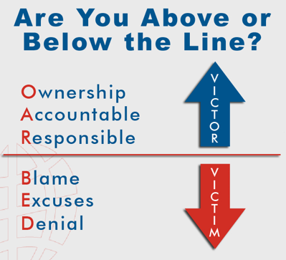
Other Basic Expectations:
- Students will turn work in on time…
- consistently work hard…
- not expect to be spoon fed material...
- take responsibility for their own learning…
- strive to think like a historian…
- back up opinions with evidence…
- be honest and do their own work…
- communicate and ask for help when needed…
- follow school policies
- Strive to live above the line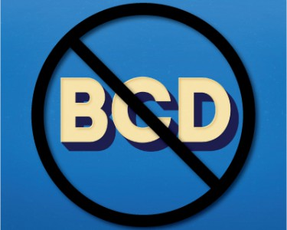
- No BCD
  - Blaming other
  - Complaining about your circumstances
  - Defending yourself for not doing what you should of.

1. One spiral notebook, standard size from 70 pages to 150 pages. 70 page spiral is recommended. The spiral should be brought to class each day.
2. Yellow, 8 ½ X 11 writing pad, used for writing assignments and tests, to be left inside in classroom, may be college or wide ruled

3. One Three-ring binder (or some means of storing any papers that may be distributed and tracking your notes).

4. Ink pens, almost all work not completed digitally will be completed in ink!

5. High quality eraser (This is optional but comes in handy on scantrons/multiple choice tests, because poor erasures may cause grading errors)

6. #2 Pencils to be used ONLY on zipgrader… all other work will be completed digitally or in ink

7. GUIDEBOOK United States History: Preparing for the Advanced Placement Examination by John J. Newman (2016 revised edition) published by AMSCO. 