DISCIPLINARY PRACTICES & REASONING SKILLS

Below is an excerpt from a historical document. Read the document and answer the questions that follow.

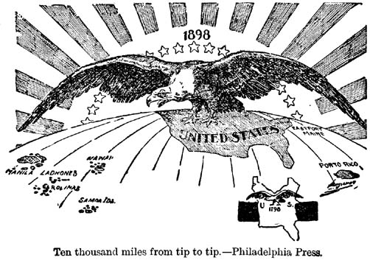
Causation…
Identify an event, person, or process that caused the above historical phenomena:
___________________________________________________________
___________________________________________________________
___________________________________________________________
___________________________________________________________
___________________________________________________________
Causation…
Identify an event/reaction that was caused by the above historical phenomena:
___________________________________________________________
___________________________________________________________
___________________________________________________________
___________________________________________________________
___________________________________________________________
Comparison…
Compare the above issue with a similar document/event/phenomena of the time period:
___________________________________________________________
___________________________________________________________
___________________________________________________________
___________________________________________________________
___________________________________________________________
Continuity and Change Over Time…
How did the document mentioned above demonstrate continuity in America? Change?
___________________________________________________________
___________________________________________________________
___________________________________________________________
___________________________________________________________
___________________________________________________________
___________________________________________________________
___________________________________________________________
___________________________________________________________
___________________________________________________________
___________________________________________________________

Periodization…
How did the information in the above document describe or incite a (turning point) change in American history?
___________________________________________________________
___________________________________________________________
___________________________________________________________
___________________________________________________________
___________________________________________________________

Synthesis…
Describe a parallel or similar event to the information in the above document it must be from another time period in American history, a different geographic location, OR from a different category than reflected above (this document is Political).
___________________________________________________________
___________________________________________________________
___________________________________________________________
___________________________________________________________
___________________________________________________________

