WWII Key People
 | 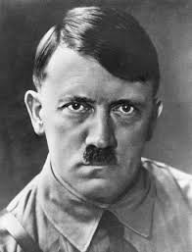 | 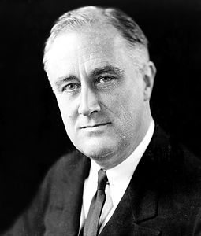 | 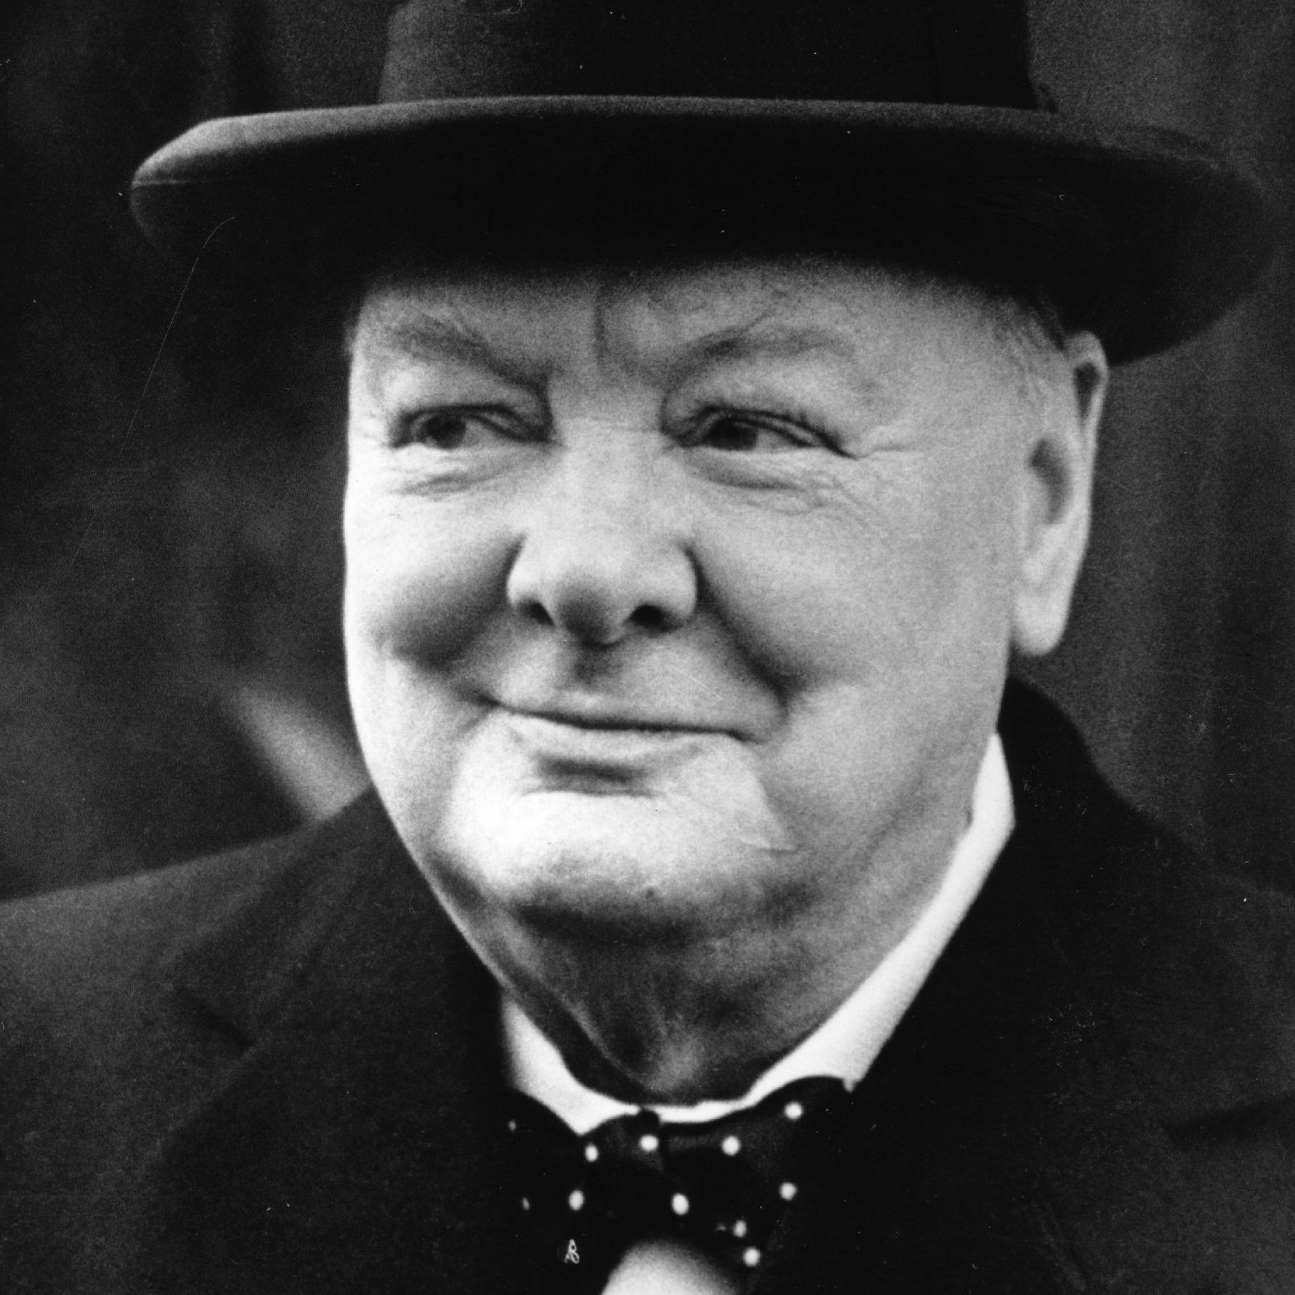 | 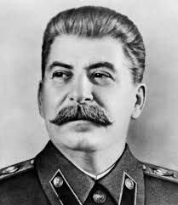 | 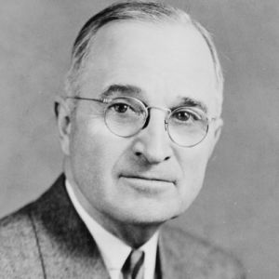 | 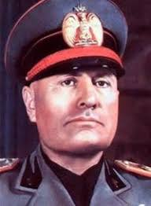
Name
Country
Personality:  Axis or Allied:  Goals during power:  One positive:  One negative: | 1.  2.  3.  4.  5. | 1.  2.  3.  4.  5. | 1.  2.  3.  4.  5. | 1.  2.  3.  4.  5. | 1.  2.  3.  4.  5. | 1.  2.  3.  4.  5.

