John Adams-Federalists  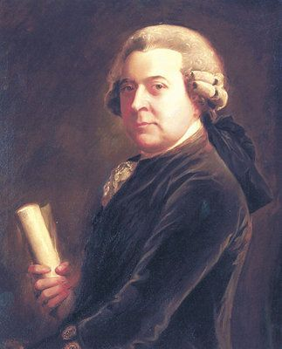 | Thomas Jefferson-Democratic Republican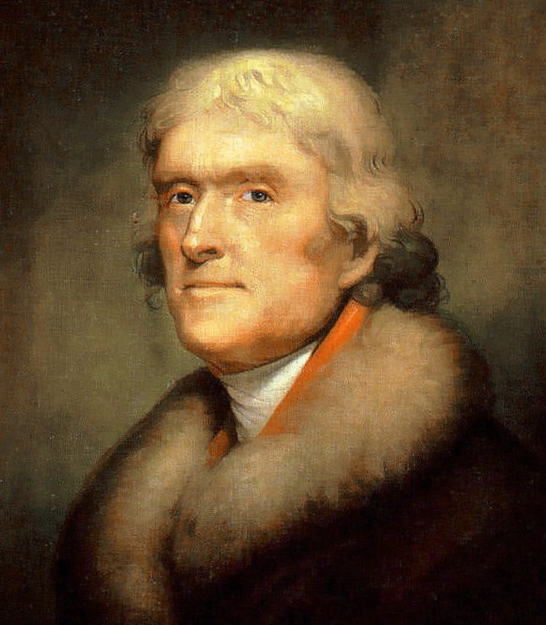
Plan for Running the Government
Favored a strong national government  • Favored limiting the power of the states  • Believed the common people were incapable of governing themselves  • Wanted to develop industry nationally  • Against too much individual freedom | Favored a weak national government  • Supported states’ rights  • Believed the common people were capable of governing themselves. Wanted more people involved in government.  • Favored farmers and small business  • Favored freedom of speech and the press
Portions of Society who Supported the Candidates
Bankers, manufacturers, merchants | Small farmers, settlers, plantations owners, artists, shopkeepers
Regions of Support
New England and Mid-Atlantic states | Southern and Western states
Positions on Relations with Foreign Countries
Encouraged good relations and trade with Great Britain. Distrusted France, which had just experienced a revolution. | Encouraged good relations and trade with France. Distrusted Great Britain who had fought the U.S. to prevent their independence.
Peaceful Transition of Power
On March 1, 1801, Thomas Jefferson was inaugurated as third president of the United States. When it was time for Jefferson to be sworn into office and take control of the government from the Federalists, John Adams quietly left town and returned to his home in Massachusetts. Before the inauguration, Adams had appointed hundreds of Federalist judges to the bench and left office defeated and depressed, but he didn’t contest the outcome or call out the army to keep him in power. The election also brought changes in the Congress, where the Democratic Republicans had gained a majority. The outgoing Federalist legislators also left office without a fuss. While attempting to reduce tensions between the different political groups in the country, Jefferson also pushed for significant differences in the way government would be run. The Democratic-Republicans set a new course for the country by repealing the Alien and Sedition Acts or allowing them to expire. Jefferson turned the efforts of the country to the West, expanding and absorbing territories. He called for a return to the principles of the American Revolution, supporting the rights of the states, and restoring the rights of the people.
The Importance of the Election of 1800
The election of 1800 was remarkable for a number of reasons. It marked the first time that power was peacefully transferred from one political party to another. Though both sides believed the election was crucial to the survival of the nation, the departing Federalists left government quietly. The Democratic-Republicans reversed many Federalist policies, but did not attempt to destroy the Federalist Party. The Federalist Party pulled itself apart from within as splinter factions continued to struggle for what little power remained. The peaceful transition of power set a pattern for future elections. Though not apparent at the time, the idea that one party could leave government peacefully also implied it could return. A minority party could still have influence and power in a democracy as long as it had some support from the people. Similarly, the election also proved that citizens could successfully change the course of the government when they saw fit. The deadlocked election brought about a change to the Constitutional. The Twelfth Amendment called for electors to cast separate votes for president and vice president. [Prior to this change, electors voted for two candidates for president, with the person receiving the most votes becoming president and the second-place candidate vice president. Such a practice could lead not only to a tie vote, as in the 1800 election, but also to the awkward circumstance of political rivals having to serve as partners in the executive branch.]
Analysis: Support or Refute the following statement: The Revolution of 1800 was just as important in the development of our nation as the American Revolution.

ACTIONS SPEAK LOUDER THAN WORDS
As you watch the clip from Ken Burns “Thomas Jefferson” mark an X whether his actions resembled more Democratic Republican, Moderate, or Federalists values. Then answer the Analysis Question.

Action during Jefferson’s Presidency | Democratic Republican | Moderate | Federalists
Wore simple dress and chose to walk to his inaugural
Inaugural Speech
Pardoned those that had been locked up from the Alien and Sedition Acts.
Cut Spending
Shrank Navy
Abolished Federal Jobs where he felt necessary
Louisiana Purchase
Lewis and Clark Expedition-Corps of Discovery
Owning Slaves
US Neutrality in Napoleonic Wars
Fighting Barbary Pirates
Embargo Act of 1807
Support or refute the following statement:
During Jefferson’s presidency he was acting as a Federalist while calling himself a Democratic-Republican. Give three pieces of evidence to support your view.

