Name________________________ APUSH Period ___________

Sourcing exercise: Using the document below, create a “sourcing” statement for each of the following: point of view, historical context, author’s purpose, and intended audience.

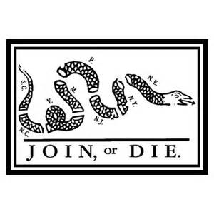

BACKGROUND:
"Join, or Die" is a well-known political cartoon, created by Benjamin Franklin and first published in his Pennsylvania Gazette on May 9, 1754.The original publication by the Gazette is the earliest known pictorial representation of colonial union produced by a British colonist in America. It is a woodcut showing a snake cut into eighths, with each segment labeled with the initials of one of the thirteen American colonies or region. New England was represented as one segment, rather than the four colonies it was at that time. In addition, Delaware (then a part of Pennsylvania) and Georgia were omitted completely. Thus, it has 8 segments of snake rather than the traditional 13 colonies. The two northernmost British American colonies at the time, Nova Scotia and Newfoundland, were not represented, nor were any British Caribbean possessions. The cartoon appeared along with Franklin's editorial about the "disunited state" of the colonies, and helped make his point about the importance of colonial unity. This cartoon was used in the French and Indian War to symbolize that the colonies needed to join together with Great Britain to defeat the French and Indians. It became a symbol of colonial freedom during the American Revolutionary War.
SOURCE: Wikipedia (yes, I know…I shouldn’t have but….)

Be subtle! Try not mention the italicized phrase in your sentences!

WHAT was the Point of View of Ben Franklin? ____________________________
____________________________________________________________
____________________________________________________________
____________________________________________________________
____________________________________________________________

Describe the historical context surrounding the event represented in the political cartoon. ______________________________________________________
____________________________________________________________
____________________________________________________________
____________________________________________________________
____________________________________________________________

WHAT is the purpose of Ben Franklin in producing this political cartoon? _________
____________________________________________________________
____________________________________________________________
____________________________________________________________
____________________________________________________________

WHAT was Ben Franklin’s intended audience of the political cartoon?____________
____________________________________________________________
____________________________________________________________
____________________________________________________________
____________________________________________________________

