Graphic Organizer 2.1
A Long Train of Abuses and Usurpations
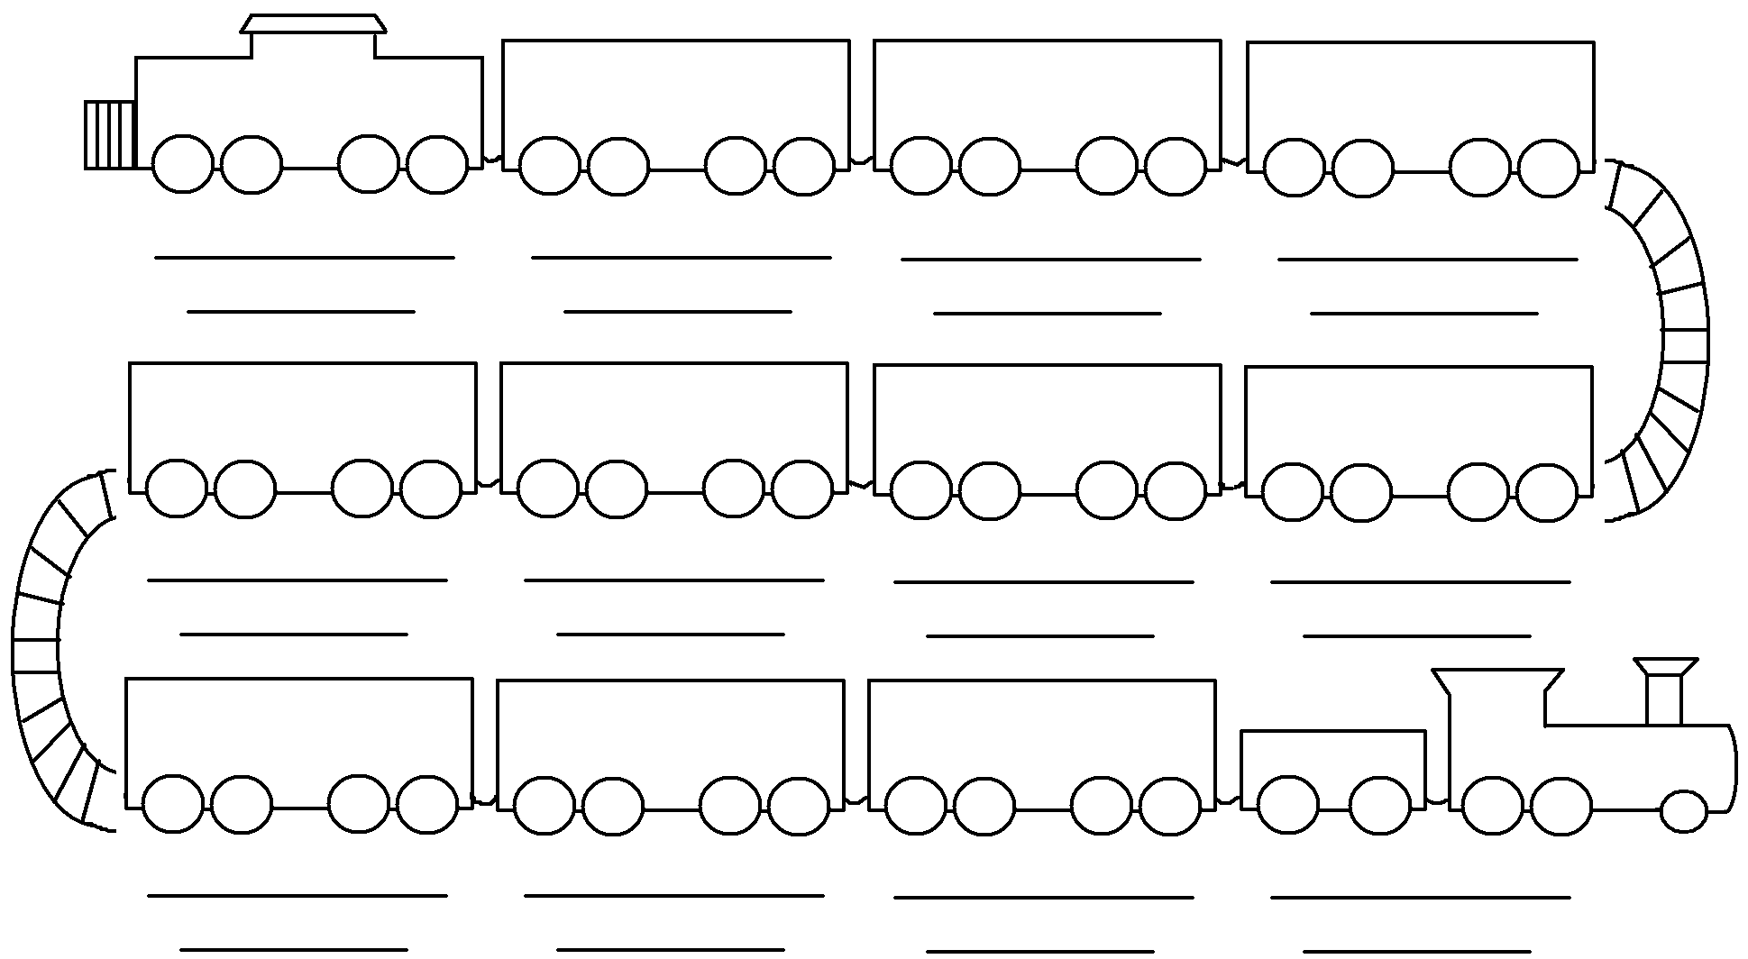

Prudence, indeed, will dictate that Governments long established should not be changed for light and transient causes; and accordingly all experience hath shewn that mankind are more disposed to suffer, while evils are sufferable… But when a long train of abuses and usurpations, pursuing invariably the same Object evinces a design to reduce them under absolute Despotism, it is their right, it is their duty, to throw off such Government, and to provide new Guards for their future security.
-- Thomas Jefferson, Declaration of Independence (1776)

Proclamation of 1763 Sugar Act Stamp Act Townshend Acts Boston Massacre
Tea Act Coercive Acts Lexington and Concord Bunker Hill Prohibitory Act

