Alexander Hamilton-Federalists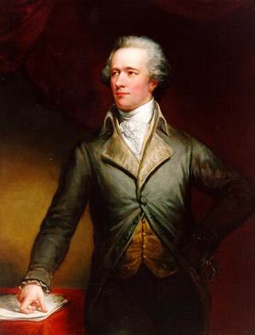
Personal Background
Hamilton was born in the West Indies and raised on the Caribbean island of St. Croix. When Hamilton was 13, a devastating hurricane struck the island. Hamilton wrote a vivid description of the storm that impressed all who read it. A few St. Croix leaders arranged to send the talented teenager to New York, where he could get the education he deserved.
With no money or family connections to help him rise in the world, he made his way on ability ambition, and charm. George Washington spotted Hamilton’s talents early in the Revolutionary War. Washington made the young man his aide-de-camp or personal assistant. Near the end of the war, Hamilton improved his fortunes by marrying Elizabeth Schuyler. His new wife came from one of New York’s richest and most powerful families. With her family’s political backing, Hamilton was elected to represent New York in Congress after the war. Later, he served as a delegate from New York to the Constitutional Convention.
delegate – somebody chosen to represent their state
View of Human Nature - (human nature – human behavior that does not change over time)
Hamilton’s view of human nature was shaped by his wartime experiences. All too often, he had seen people put their own interests and personal profit above patriotism and the needs of the country.
Most Federalists shared Hamilton’s view that people were basically selfish and out for themselves. For this reason, they distrusted any system of government that gave too much power to “the mob,” or the common people. Such a system, said Hamilton, could only lead to “error, confusion, and instability.”
Best Form of Government
Federalists believed that the country should be ruled by “best people” – educated, wealthy, public-spirited men like themselves. Such people had the time, education, and background to run the country wisely. “Those who own the country,” said Federalist John Jay bluntly, “ought to govern it.”
Federalists favored a strong national government, they believed in loose construction, a broad or flexible interpretation of the Constitution. They hoped to use the new government’s powers under the Constitution to unite the quarreling states and keep order among the people. In their view, the rights of the states were not nearly as important as national power and unity.
Ideal Economy
Hamilton’s dream of national greatness depended on the United States developing a strong economy. In 1790, the nation’s economy was still based mainly on agriculture. Hamilton wanted to expand the economy and increase the nation’s wealth by using the power of the federal government to promote business, manufacturing, and trade.
In 1790, Hamilton presented Congress with a plan to pay off all war debts as quickly as possible. If the debts were not promptly paid, he warned, the government would lose respect both at home and abroad.
Hamilton’s plan for repaying the debts was opposed by many Americans, especially in the South. Most southern states had already paid their war debts. They saw little reason to help states in the North pay off what they still owed.

Thomas Jefferson-Democratic-Republicans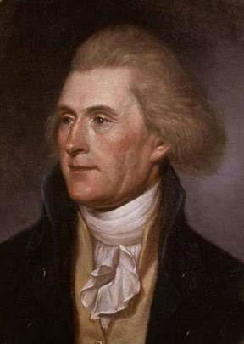
Personal Background
Jefferson was born in Virginia to an wealthy and respected family. One of ten children, he was gifted with many talents. As a boy, he learned to ride, hunt, sing, dance, and play the violin. Later, he carried a violin with him in all his travels.
With land inherited from his father, Jefferson set himself up as a Virginia tobacco planter. Once he was established as a planter, Jefferson entered Virginia politics. As a politician, he lacked the ability to make stirring speeches. Instead, Jefferson spoke eloquently with his pen. His words in the Declaration of Independence and other writings are still read and admired today.

View of Human Nature
Jefferson’s view of human nature was much more hopeful than Hamilton’s. He assumed that informed citizens could make good decisions for themselves and their country. “I have so much confidence in the good sense of men.” Jefferson wrote when revolution broke out in France, “that I am never afraid of the issue where reason is left free to exert her force.”
Jefferson had great faith in the goodness and wisdom of people who worked the soil – farmers and planters like himself. “State a problem to a ploughman and a professor,” he said, and “the former will decide it often better than the latter.”
human nature – human behavior that does not change over time
informed – having enough knowledge to understand something
exert – to make a strenuous physical or mental effort
ploughman – farmer

Best Form of Government
Democratic-Republicans had no patience with the Federalists’ view that only the “best people” should rule. To Democratic-Republicans, this view came close to monarchy, or rule by a king.
Democratic-Republicans believed that the best government was the one that governed the least. A small government with limited powers was most likely to leave the people alone to enjoy the blessings of liberty. To keep the national government small, they insisted on a strict construction, or interpretation, of the Constitution. The Constitution, they insisted, meant exactly what it said, no more and no less. Any addition to the powers listed there, was unconstitutional (against the law) and dangerous.

Ideal Economy
Like most Americans in the 1790s, Jefferson was a country man. He believed that the nation’s future lay not with Federalist bankers and merchants, but with plain, Democratic-Republican farm folk. “Those who labor in the earth,” he wrote, “are the chosen people of God, if ever He had a chosen people.”
Democratic-Republicans favored an economy based on agriculture. They opposed any measures designed to encourage the growth of business and manufacturing. (to make something into a product using raw materials)

